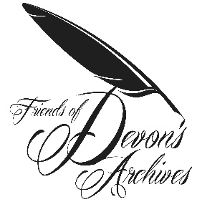
SPRING MEETING 2018
‘Unwritten Archives’
BOOKING FORM
Saturday 28 April 2018 (9:45 am – 4:45pm)
Torquay Museum, 529 Babbacombe Road, Torquay TQ1 1HG

Name(s)

Contact email:

Contact telephone:

To book place(s), please return this form to Brian Carpenter, Friends of Devon’s Archives, Devon Heritage Centre, Great Moor House, Bittern Road, Sowton, Exeter EX2 7NL, or email Brian.Carpenter@swheritage.org.uk. The event is £10.00 for FODA and DHS members, £12.99 for non-members. This sum can be paid on the day as long as booking made in advance. Cheques should be made payable to ‘Friends of Devon’s Archives’.
Tea/coffee will be provided on arrival, during the mid-morning break and during the afternoon break. Attendees will need to bring their own lunch or purchase lunch from the café. Please note that you cannot consume your own food within the museum. Please also note that the café at the museum only accepts cash.
For information on getting to Torquay Museum, see:
http://www.torquaymuseum.org/visit/getting-here

