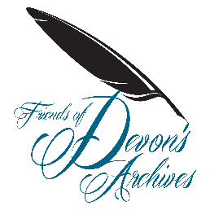

The Friends of Devon’s Archives invite you to the Annual General Meeting on 16th November 2022 at 11am at The Box, Plymouth.

Programme

11am FODA AGM in the conference room, The Box, Plymouth – NB: coffee can be purchased in cafe before the meeting
11:30am Tour of The Box archives with Claire Skinner

Lunch can be purchased in café and members are welcome to have a self -guided tour of The Box.

For more information about The Box, including directions, parking and facilities, please visit their website at https://www.theboxplymouth.com/

Please RSVP to the Secretary, Clare Maudling, at clare@maudling.co.uk

