FoDA’s NORDEN PROJECT
17th Century Communities in Devon: People and their Landscape in the Norden Survey of 1613.
Frances Billinge and David Stone
July 2020

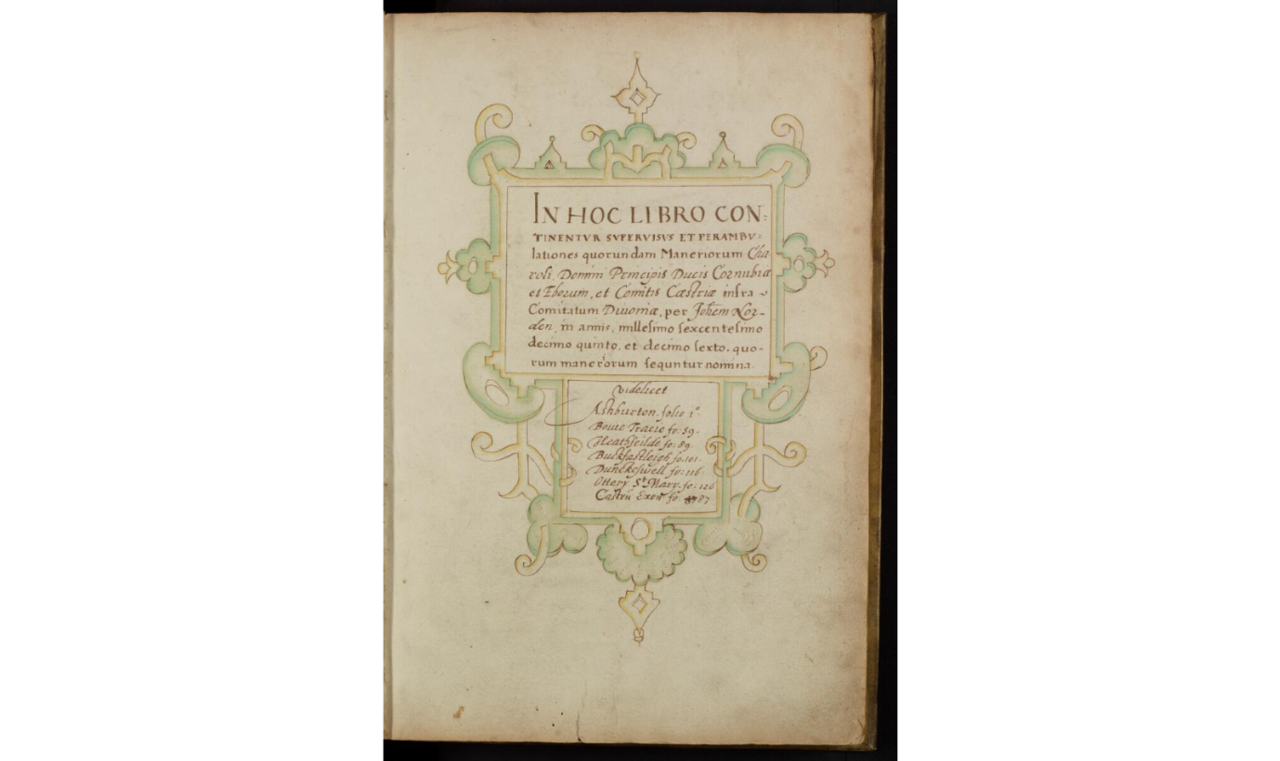

Front page of Norden Survey of Various Manors of Devon by courtesy of London Metropolitan Archives

BACKGROUND
Through the research of a member of FoDA, John Norden’s 1613 survey of various manors in the County of Devon came to light. In March 2019, FoDA held a successful seminar jointly with the Devon Archaeological Society to raise awareness of the survey and to seek volunteers to help work on it. There was much enthusiasm among members of FoDA and other societies and, at the end of 2019, FoDA put in a successful bid to the National Lottery Heritage Fund so that the survey could be transcribed, translated and published, both in a printed edition and online.
John Norden’s was a surveyor and cartographer who surveyed Crown lands for James I in the early 1600s. Norden’s work is fully described by Frederick Lewis in the Oxford Dictionary of National Biography.¹ Further information is also given in Heather Lawrence’s article of 1985.²
Needing to raise money, the Crown had started to sell some of its estate from the middle of the 1500s.³ This policy was continued by James I who, in 1612, granted John Norden surveyorship of the King’s lands in several counties including Devon in preparation for the sale of these lands.⁴
Famously, Norden’s surveys were sometimes accompanied by a map, but in many instances these documents were (as they had been for centuries) simply a written description of manorial land and resources. In Northamptonshire, for example, his written description of the parish included mileage between places and lists of the landholders.⁵ He undertook his survey of the Crown lands of Devon in 1613-4 and this was written-up in manuscript form, without maps, by 1615.⁶
Norden’s survey of the Devon Crown lands covers Ashburton, Bovey Tracey, Bradninch, Buckfastleigh, Dunkeswell, Exeter Castle, Heathfield, and Ottery St Mary. The surveys, which together form four hundred pages of a single manuscript, are written in a mixture of Latin and English and are available on-line at the London Metropolitan Archive. Frank Kitchen explained the methods which Norden used in his surveys, which varied depending on what was required.⁷ Norden attended courts, examined records, and physically inspected the ground, compiling a register of holdings, tenants, values, and obligations, together with many incidental but illuminating details. He made marginal notes to raise queries, using manicules for particularly questionable points of legality. Consequently, the surveys contain a wealth of social and economic information about the areas covered.

THE PROJECT
Dr David Stone is leading the project and Ros Palmer has kindly agreed to be the administrator for it. Although the lockdown coincided with the start of the funded phase of the project and forced the cancellation of the first formal meeting of this phase (which was due to be held at the Devon Rural Archive in late March), the last few months has still seen considerable progress being made. We have had several new volunteers join us, bringing the total number of transcribers/translators who are working on the eight manorial surveys to 19. As well as being in email contact with volunteers, David has held Zoom meetings with the majority of those involved in order to introduce people to one another, to help with any issues that have arisen, and to discuss the possibilities for local, contextual research. Good progress has already been made on transcribing and translating some of the surveys: indeed, transcriptions for some of the manors are already very well advanced. In Zoom meetings with volunteers, David has been keen to stress the need for consistency across the different parishes, which is one of reasons why, at this stage, it is important to work towards a transcription as well as a translation of the surveys.
The project will also entail the carrying out of research into the local history of the different manors, allowing the survey to be put into in context and the history of personal names, field names, and manor boundaries to be explored. This will hopefully enable connections to be made with later documents but also encourage volunteers to peer back into the sixteenth century and perhaps even into the medieval period in the search for information about local people and their landscape. As Bradninch, for example, was a manor held by the duchy of Cornwall, the existence of documentary references casting light on the material contained in the Norden survey is highly likely. Such contextual work will not only inform the final printed and on-line edition of the work, as local talks, walks, and the ‘beating of bounds’ will, in due course, also be arranged.
To bring Norden’s work in a full circle, it may also prove possible to map some areas and aspects covered by the survey. This may, for example, include consideration of park and barton land, as well as the fieldscape and land use more generally. Reconstruction of the landscape over time would be greatly aided by nineteenth-century tithe maps and Ordnance Survey maps, together with the use of Geographic Information Systems. Such a method, of course, is already used by Know Your Place.
The project will be a main item at the 2020 FoDA AGM on 24 November, to be held at Devon Rural Archive. All FoDA members are welcome to be part of this project: if you are interested, please contact: davidstonemedievalist@gmail.com or make your interest known through the FoDA web-site. There will be a progress report in the next Newsletter.

REFERENCES
- Frederick Lewis 2008. John Norden. Oxford Dictionary of National Biography (Oxford)
- Heather Lawrence, 1985. John Norden and his Colleagues, Surveyors of Crown Lands in The Cartographic Journal 22, vol. I, pp.54-5.
- All of the following describe the selling of Crown land - John Kew, 1967. The land Market in Devon 1536-1558. Unpublished Ph. D. thesis University of Exeter.; John E. Kew, 1967. Mortgages in Mid-Tudor Devonshire in Trans. Devon. Assoc., Advmt Sci.vol.99, pp.165-179; John Kew, 1970. The Disposal of Crown Lands and the Devon Land Market, 1536-58 in Agricultural History Review xviii, vol.18, pt 1, pp.93-105.
- Calendar of State Papers Domestic Series James I, 1611-1618, p. 158. 26 November 1612, ed. Mary Anne Everrett Green, HMSO, 1967.
- John Norden,1610 published 1720. Speculi Britanniae Pars Altera: or A Delineation of Northamptonshire, (London).
- London Metropolitan Archives. John Norden ; 1615-16 Survey of Devon manors CLA / 044/05/04, available on line www.cityoflondon.gov.uk At the time the manors were mortgaged to the Corporation of London which is why the document is in the City of London Archives.
- Frank Kitchen,1997. John Norden c. 1547-1625, Estate Surveyor, Topographer, County Mapmaker and Devotional Writer in Imago Mundi 49, pp. 43-61. Page 50 describes the background of Norden’s work and page 54 describes Norden’s methods.

